**Assignment2**

1. **Curves**

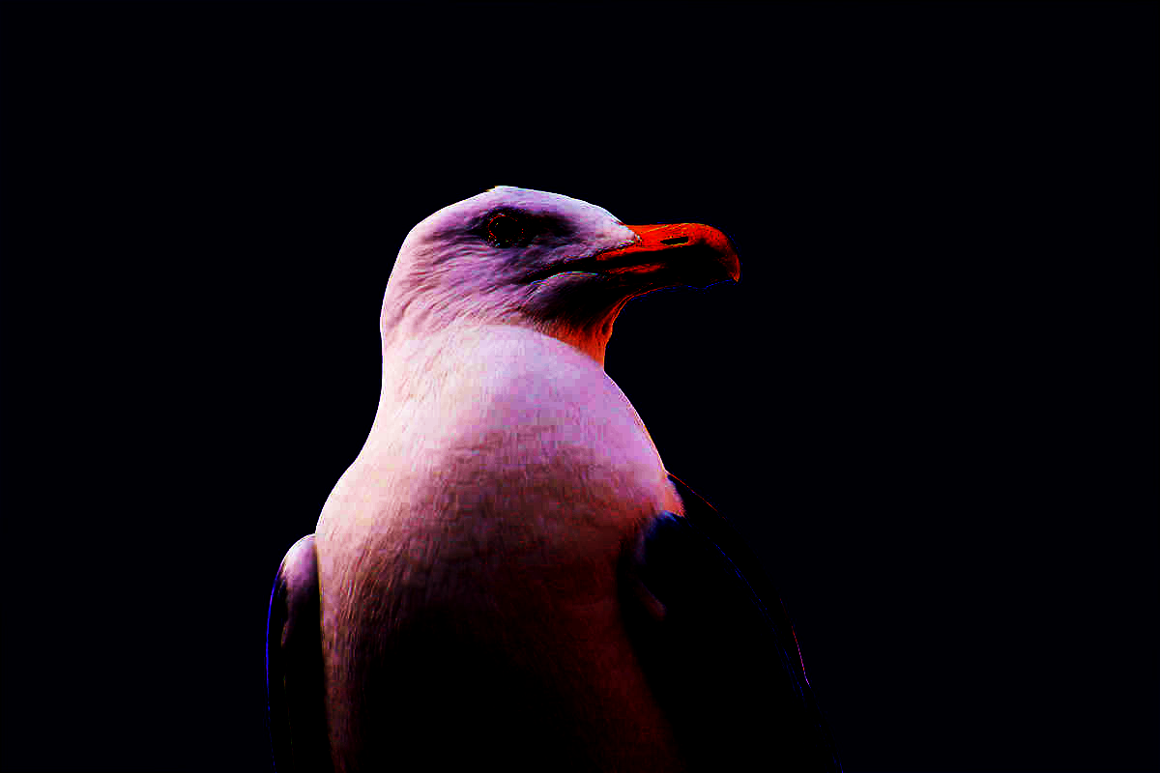

1. **Levels**

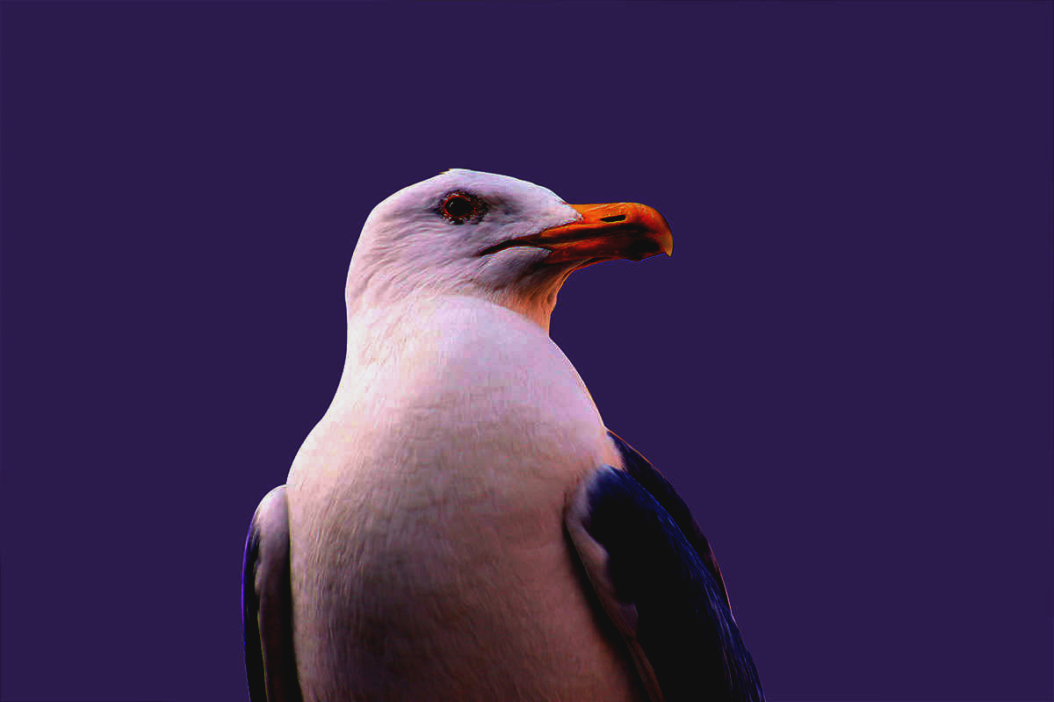

1. **Black&white**

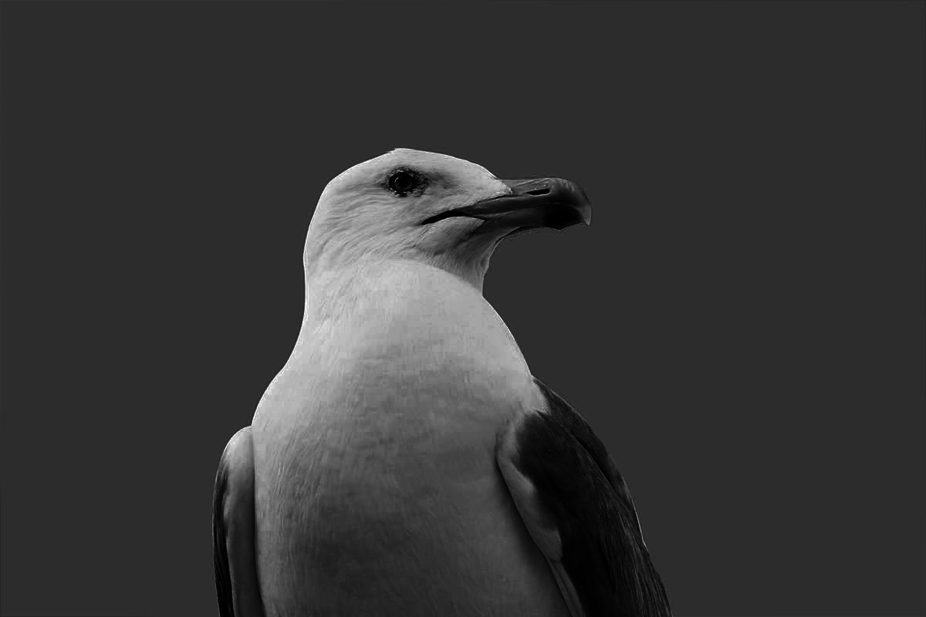

1. **Hue/saturation**

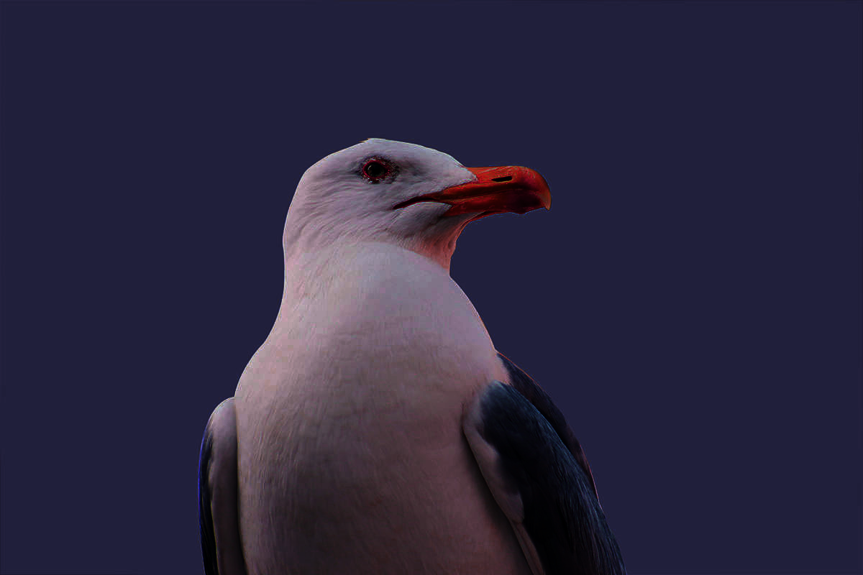

1. **Brightness&contrast**

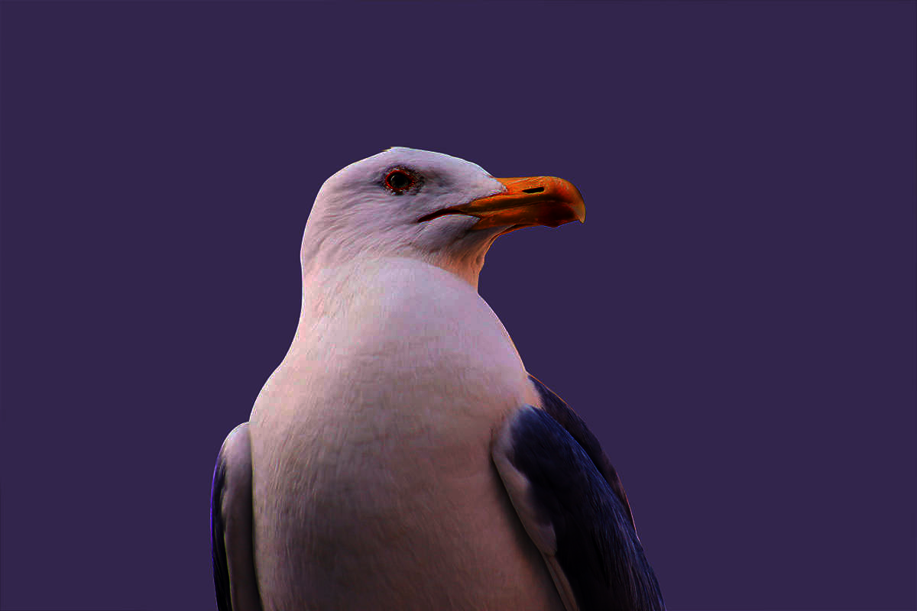

1. **Vibrance**

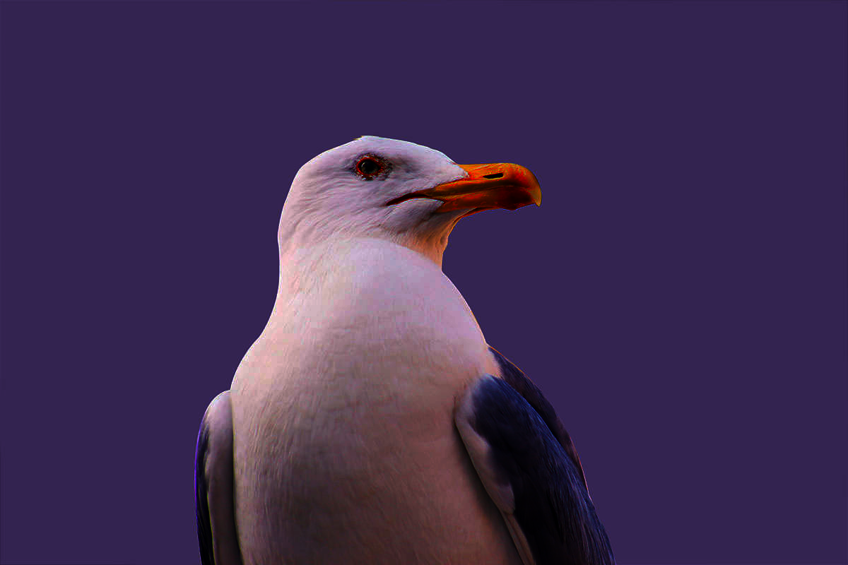

1. **Camera raw**

* **Temperature- increase the value +7**
* **Tint – increase the value +20**
* **Exposure – decrease the value-20**
* **Contrast – increase the value +20**
* **Highlight – increase the value +60**
* **Shadow- increase the value +20**
* **White – decrease the value-70**
* **Black – decrease the value -20**
* **Clarity – increase the value +25**
* **Vibrance – increase the value +45**
* **Saturation- increase the value +45**

**Before**

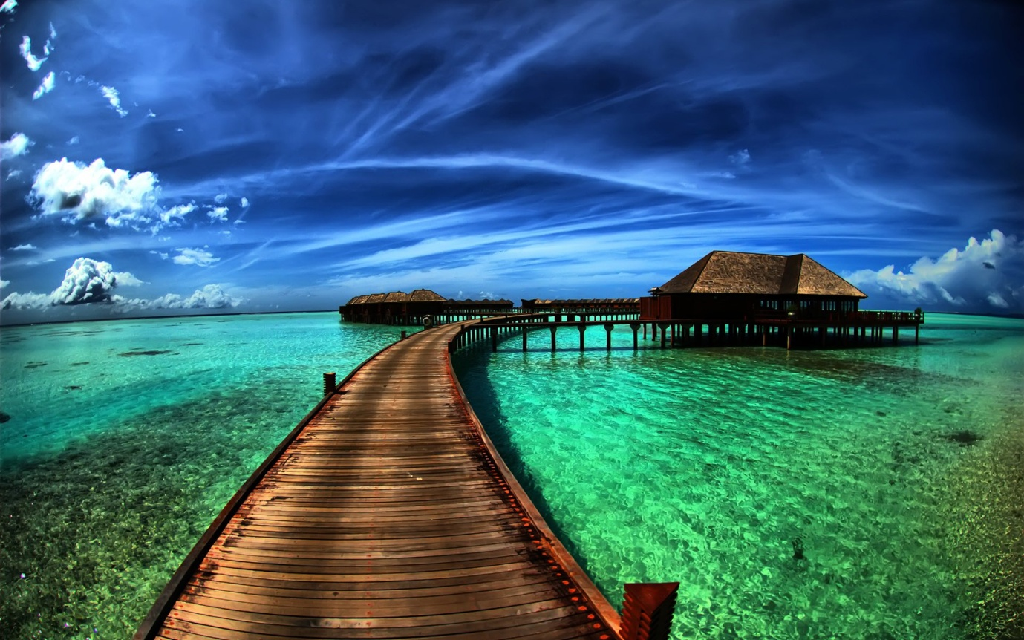

**After**

